**HardwareStore UML Designs**

1. **Use Cases**

**Use Case: Login to Customer Online Account**

* *Customer logins to their respective account to complete actions that need an account. If account does not exist, the user is prompted to create a customer account.*

**Use Case: Create a customer service message**

* *Customer logins to their account to create customer service message. If account does not exist, the user is prompted to create a customer account.*

**Use Case: Create an online transaction**

* *Customer create a transaction for the purchase. If account does not exist, the user has the option to create a customer account.*

**Use Case: Create Customer Account on Website**

* *User is prompted to create a Customer account.*

**Use Case: Edit Customer Account on Website**

* *User logins to their account to edit any information allowed by the system. If account does not exist, the user is prompted to create a customer account.*

**Use Case: Create Sale Transaction**

* *Employee creates a sale transaction given the information about the sale from the customer.*

**Use Case: Complete Online Purchase**

* *Customer completes their purchase through the website*

**Use Case: Print receipt**

* *Customer has the option to print receipt after completing their online purchase*
* *Employee prints receipt after completing their sale transaction.*

**Use Case: Update Customer Account**

* *If needed, the employee can edit a customer’s account information.*

**Use Case: Complete Sale Transaction**

* *Employee completes their respective sale transaction with the information given from the created sale transaction.*

**Use Case: Create Customer Account**

* *Employee creates a customer account with their respective customer they are assisting in store.*

**Use Case: Reply to Customer Service Message**

* *Employee responds to the customer’s given question through their online customer service website.*

**Use Case: Create Employee or Administrator Account**

* *Administrator creates a new employee or administrator account when needed/asked to do so.*

**Use Case: Edit Employee or Administrator Account**

* *Administrator edits an employee or administrator’s account information when needed/asked to do so.*

**Use Case: Print Financial Documents**

* *Administrator prints the financial documents.*

**Use Case: Update Income | Expenses and Profits Reports**

* *Administrator updates the income expense and profit reports.*

**Use Case: Pay Expenses**

* *Administrator pays expenses.*

**Use Case: Update Accounting Information**

* *System automatically updates the accounting information when information is changed or updated.*

**Use Case: Update User Records**

* *System automatically updates user records when information is changed or updated.*

**Use Case: Update Inventory**

* *System automatically updates inventory records when information is changed or updated.*

1. **Use Case Diagram**

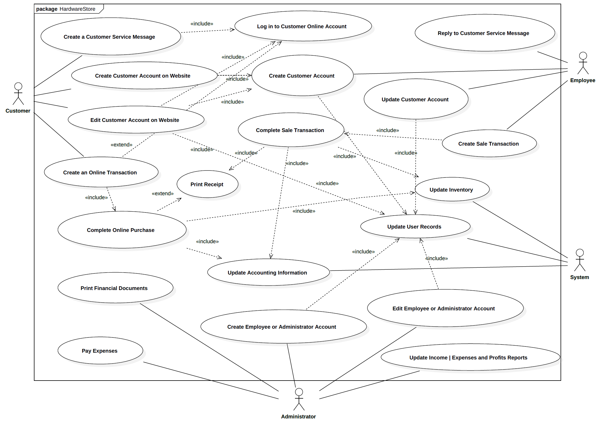

1. **CRC Cards**

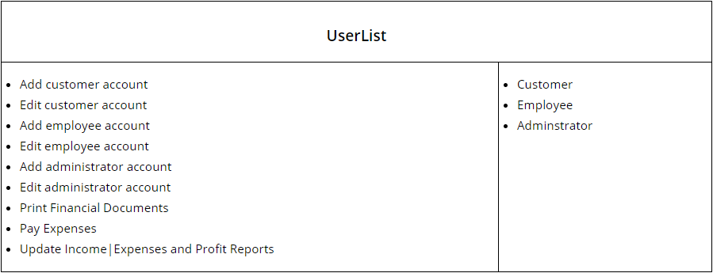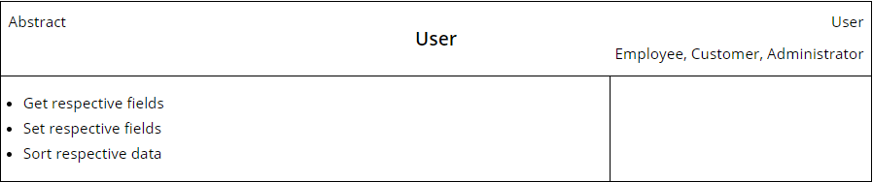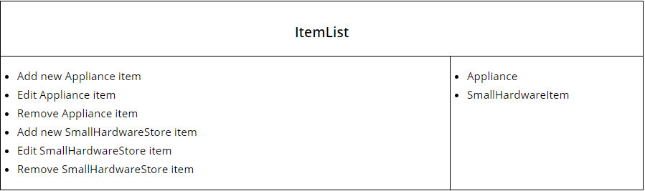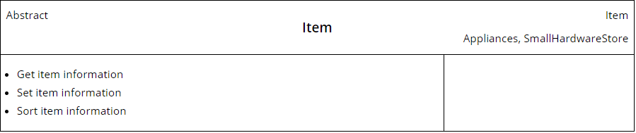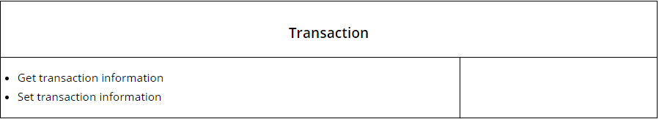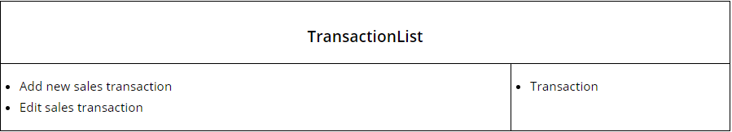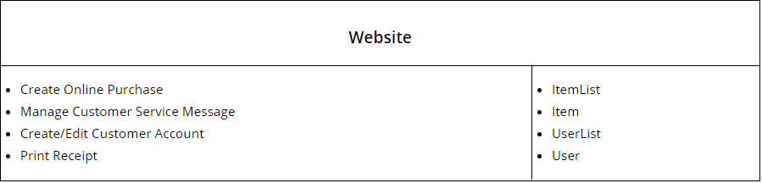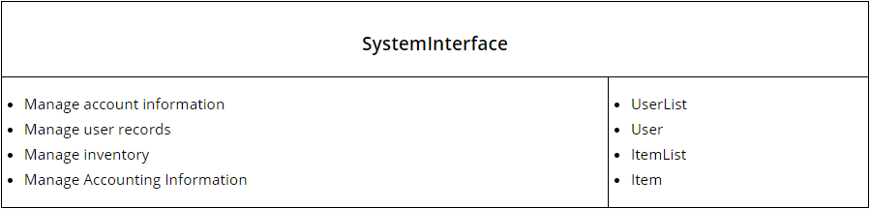

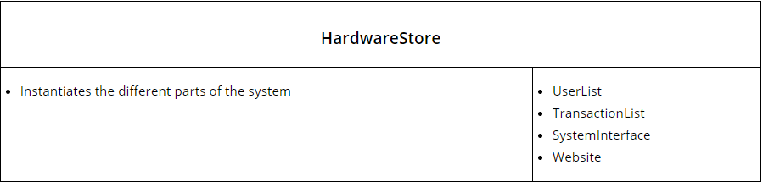

1. **Class Diagram**

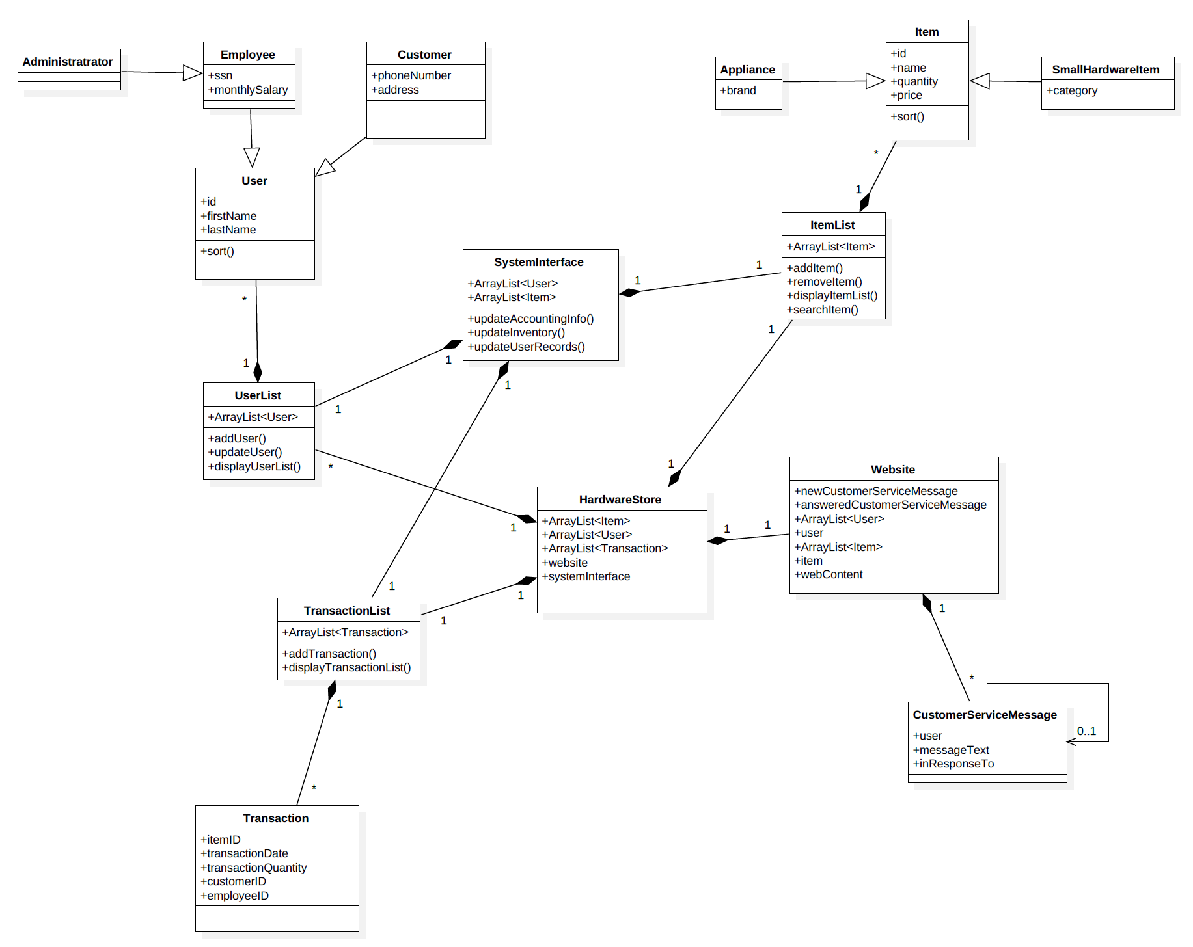

1. **Sequence Diagram**

